**IMPLEMENTING KNN ALGORITHM**

**-22pt27**

import pandas as pd

from sklearn.model_selection import train_test_split

import math

from sklearn.preprocessing import StandardScaler

import statistics

import matplotlib.pyplot as plt

from matplotlib.colors import ListedColormap

df = pd.read_csv('/content/Implementing KNN Algorithm.csv',sep = '\t',engine = 'python')

y=df['target']

**#normalize**

sc = StandardScaler()

df = pd.DataFrame(sc.fit_transform(df), columns = df.columns)

x1=df['sepal length (cm)']

x2=df['sepal width (cm)']

x3=df['petal length (cm)']

x4=df['petal width (cm)']

X1_test,X1_train, X2_test,X2_train,X3_test,X3_train,X4_test,X4_train,y_test,y_train = train_test_split(x1,x2,x3,x4,y, test_size=0.05, random_state=0)

**def visvualization(x1,x2,x3,x4,y):**

    # Create a figure for the plots

    plt.figure(figsize=(5, 5))

    # 2D Scatter plot for Sepal Dimensions

    plt.subplot(2, 1, 1)

    plt.scatter(X1_train, X2_train, c=y_train, cmap=ListedColormap(["green","blue","yellow"]), s=50)

    plt.scatter(x1, x2, c=y, s=50)

    plt.xlabel('Sepal Length (cm)')

    plt.ylabel('Sepal Width (cm)')

    plt.title('2D Scatter Plot of Sepal Dimensions')

    # 2D Scatter plot for Petal Dimensions

    plt.subplot(2, 1, 2)

    plt.scatter(X3_train, X4_train, c=y_train, cmap=ListedColormap(["green","blue","yellow"]), s=50)

    plt.scatter(x3, x4, c=y, s=50)

    plt.xlabel('Petal Length (cm)')

    plt.ylabel('Petal Width (cm)')

    plt.title('2D Scatter Plot of Petal Dimensions')

    plt.tight_layout()

    plt.show()

**k=3 # k nearest neighbors to take can be any odd value**

**def distance(x1,x2,x3,x4):**

  d={}

  for X1,X2,X3,X4,y in zip(X1_train,X2_train,X3_train,X4_train,y_train):

    d[math.sqrt((x1-X1)**2 + (x2-X2)**2 +(x3-X3)**2 +(x4-X4)**2)]=y

  return d

for x1,x2,x3,x4 in zip(X1_test,X2_test,X3_test,X4_test):

  d=distance(x1,x2,x3,x4)

  myKeys = list(d.keys())

  myKeys.sort()

  myKeys = myKeys[:k]

  sorted_dict = {i: d[i] for i in myKeys}

  #print(sorted_dict)

  y="red"

  visvualization(x1,x2,x3,x4,y)

  if statistics.mode(sorted_dict.values()) == 0:

    y="green"

  elif statistics.mode(sorted_dict.values()) == 1:

    y="blue"

  elif statistics.mode(sorted_dict.values()) == 2:

    y="yellow"

  else:

    y="red"

  visvualization(x1,x2,x3,x4,y)

***OUTPUT***

***Before classification:-***

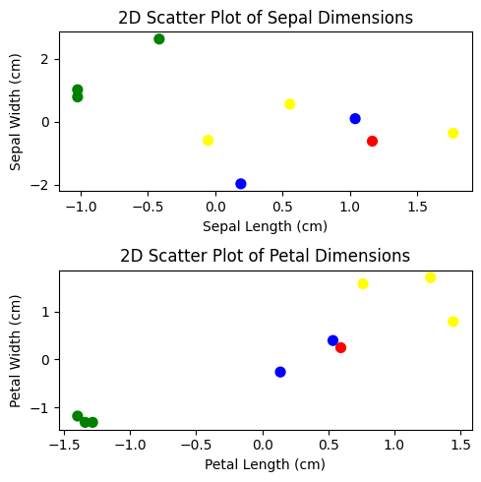

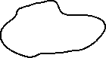

***After classification:-***

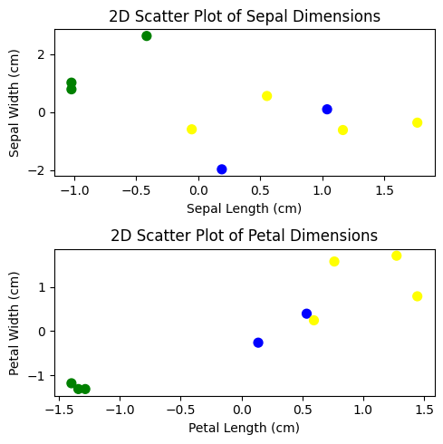

***Before classification:-***



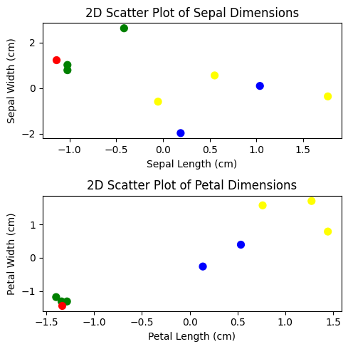

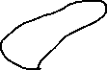

***After classification:-***

